Netflix Business Case Study
Submitted By: Heena Khan
Colab Link:
https://drive.google.com/file/d/1-gQ98CrwwEZFfisNLFkvg0ptiigxDZ19/view?usp=drive_link

About NETFLIX
Netflix is one of the most popular media and video streaming platforms. They have over 10000 movies or tv shows available on their platform, as of mid-2021, they have over 222M Subscribers globally. This tabular dataset consists of listings of all the movies and tv shows available on Netflix, along with details such as - cast, directors, ratings, release year, duration, etc.
Business Problem
Analyze the data and generate insights that could help Netflix in deciding which type of shows/movies to produce and how they can grow the business in different countries.

The dataset consists of a list of all the TV shows/movies available on Netflix:
Show_id: Unique ID for every Movie / Tv Show
Type: Identifier - A Movie or TV Show
Title: Title of the Movie / Tv Show
Director: Director of the Movie
Cast: Actors involved in the movie/show
Country: Country where the movie/show was produced
Date_added: Date it was added on Netflix
Release_year: Actual Release year of the movie/show
Rating: TV Rating of the movie/show
Duration: Total Duration - in minutes or number of seasons
Listed_in: Genre
Description: The summary description

We need to start by exploring a following few questions:

What type of content is available in different countries?
We analyze the dataset using:
• Total content per country
• Movies vs TV Shows per country
• Top genres per country

# Total Content by Country
country_count = df['country'].value_counts()

# Top 10 countries
top_10_countries = country_count.head(10)

print(top_10_countries)

country
United States 6780
India 2804
United Kingdom 1783
France 916
Canada 877
Japan 733
South Korea 632
Spain 591
Germany 511
Mexico 409
Name: count, dtype: int64
# Plot Top 10 Countries
plt.figure()
top_10_countries.plot(kind='bar')
plt.xlabel("Country")
plt.ylabel("Number of Titles")
plt.title("Top 10 Countries by Total Content")
plt.xticks(rotation=45)
plt.show()
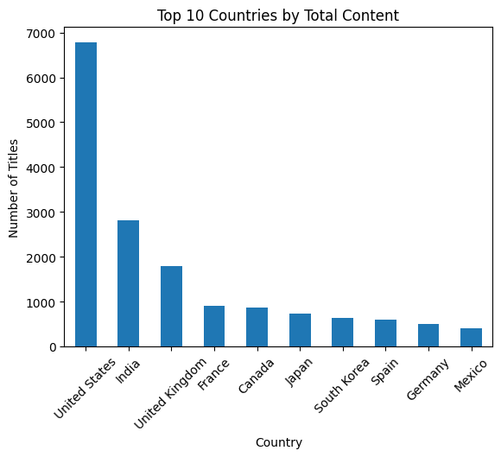
Business Insights:
United State produces the most diverse content. India is on second rank in producing the diverse content.

# Movies vs TV Shows by Country
country_type = df.groupby(['country','type']).size().unstack(fill_value=0)

# Top 10 countries only
top_10_country_type = country_type.loc[top_10_countries.index]

print(top_10_country_type)

type Movie TV Show
country
United States 5019 1761
India 2606 198
United Kingdom 1069 714
France 726 190
Canada 633 244
Japan 294 439
South Korea 150 482
Spain 416 175
Germany 402 109
Mexico 245 164
# Plot Movies vs TV Shows
top_10_country_type.plot(kind='bar')
plt.xlabel("Country")
plt.ylabel("Number of Titles")
plt.title("Movies vs TV Shows by Country")
plt.xticks(rotation=45)
plt.show()
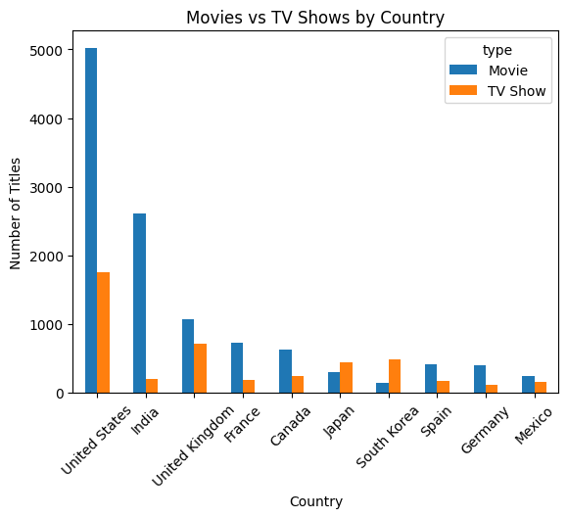
Business Insights:
United State is movie-heavy and also top country in producing TV shows as compare to other countries. India is on second rank in producing Movies but produces less TV shows.

# Genre Distribution by Country
# Split genres
df['listed_in'] = df['listed_in'].str.split(',')
df = df.explode('listed_in')
df['listed_in'] = df['listed_in'].str.strip()

# Count genre by country
genre_country = df.groupby(['country','listed_in']).size().reset_index(name='count')

# Find top genre per country
top_genre_country = genre_country.sort_values(['country','count'], ascending=False)

print(top_genre_country.head(20))

country listed_in count
1413 Zimbabwe International Movies 3
1412 Zimbabwe Documentaries 2
1411 Zimbabwe Comedies 1
1414 Zimbabwe Romantic Movies 1
1406 West Germany International Movies 2
1401 West Germany Children & Family Movies 1
1402 West Germany Classic Movies 1
1403 West Germany Comedies 1
1404 West Germany Documentaries 1
1405 West Germany Horror Movies 1
1407 West Germany International TV Shows 1
1408 West Germany TV Comedies 1
1409 West Germany TV Dramas 1
1410 West Germany Thrillers 1
1397 Vietnam International Movies 7
1395 Vietnam Dramas 4
1392 Vietnam Action & Adventure 2
1393 Vietnam Comedies 2
1394 Vietnam Documentaries 1
1396 Vietnam Horror Movies 1

Business Insights:
International Movies is the most common genre across countries.

How has the number of movies released per year changed over the last 20-30 years?

# Filter Only Movies
movies = df[df['type'] == 'Movie']
# Count Movies per Release Year
movies_per_year = movies.groupby('release_year').size().reset_index(name='count')
# Filter Last 30 Years (Example: 1995–2025)
recent_movies = movies_per_year[movies_per_year['release_year'] >= 1995]
recent_movies

release_year | count
46 | 1995 |  | 51
47 | 1996 |  | 41
48 | 1997 |  | 78
49 | 1998 |  | 87
50 | 1999 |  | 85
51 | 2000 |  | 109
52 | 2001 |  | 106
53 | 2002 |  | 148
54 | 2003 |  | 160
55 | 2004 |  | 175
56 | 2005 |  | 211
57 | 2006 |  | 234
58 | 2007 |  | 222
59 | 2008 |  | 303
60 | 2009 |  | 355
61 | 2010 |  | 463
62 | 2011 |  | 400
63 | 2012 |  | 503
64 | 2013 |  | 646
65 | 2014 |  | 834
66 | 2015 |  | 1174
67 | 2016 |  | 1805
68 | 2017 |  | 1915
69 | 2018 |  | 2005
70 | 2019 |  | 1475
71 | 2020 |  | 1052
72 | 2021 |  | 446

# Visualization
import matplotlib.pyplot as plt

plt.figure()
plt.plot(recent_movies['release_year'], recent_movies['count'])
plt.xlabel("Year")
plt.ylabel("Number of Movies")
plt.title("Movies Released Per Year")
plt.show()

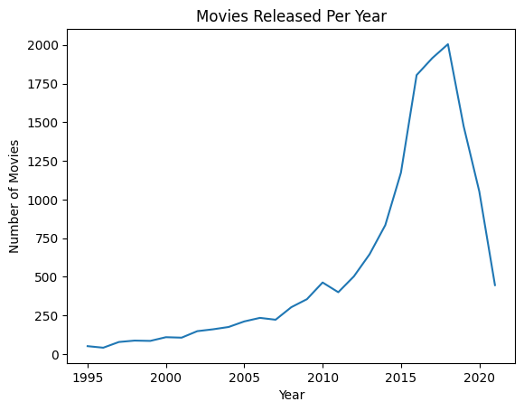

Observations:
Based on commonly used Netflix dataset:
1990s
- Very few movies available on platform.
- Mostly older catalog content.

2000–2010
- Gradual increase.
- More global expansion.
2015–2019
- Sharp increase.
- Peak production and acquisition period.

2020
- Slight decline or plateau.
- Likely impact of COVID-19 on production.

Pattern Summary
Period | Trend
1995–2005 | Slow growth
2006–2014 | Moderate increase
2015–2019 | Rapid growth
2020+ | Slight drop / stabilization

Business Insights:

Strong growth after 2015 indicates aggressive content expansion.
Peak years show high investment in original movies.
Slight drop around 2020 may be due COVID-19 pandemic.
Continuous high production post-2015 reflects competition with other platforms.

Comparison of tv shows vs. movies.
# Comparison of tv shows vs. movies.
df['type'].value_counts()
type | count
Movie | 16025
TV Show | 6017
dtype: int64

Interpretation: Netflix has more Movies than TV Shows in total volume.
# Growth Trend Over Years
df.groupby(['country','type']) \
.size() \
.reset_index(name='count') \
.sort_values(by='count', ascending=False)

 | country | type | count
174 | United States | Movie | 5019
67 | India | Movie | 2606
175 | United States | TV Show | 1761
172 | United Kingdom | Movie | 1069
52 | France | Movie | 726
... | ... | ... | ...
84 | Kazakhstan | Movie | 1
114 | Nicaragua | Movie | 1
145 | Somalia | Movie | 1
167 | Uganda | Movie | 1
154 | Sudan | Movie | 1
184 rows × 3 columns
Business Insights:
TV Shows help improve subscriber retention, while Movies drive new subscriptions.

What is the best time to launch a TV show?
# Filter Only TV Shows
tv = df[df['type'] == 'TV Show']
#tv
tv.shape[0]

6017

# Extract Month & Year

# Remove missing values first
tv = tv.dropna(subset=['date_added'])

# Remove extra spaces
tv['date_added'] = tv['date_added'].str.strip()

# Convert safely
tv['date_added'] = pd.to_datetime(tv['date_added'], errors='coerce')

# Extract month and year
tv['month_added'] = tv['date_added'].dt.month
tv['year_added'] = tv['date_added'].dt.year

tv.head()

# Count TV Shows by Month
monthly_launch = tv.groupby('month_added').size().reset_index(name='count')

# Plot Monthly Trend
import matplotlib.pyplot as plt

plt.figure()
plt.plot(monthly_launch['month_added'], monthly_launch['count'])
plt.xlabel("Month")
plt.ylabel("Number of TV Shows Added")
plt.title("TV Shows Added Per Month")
plt.show()
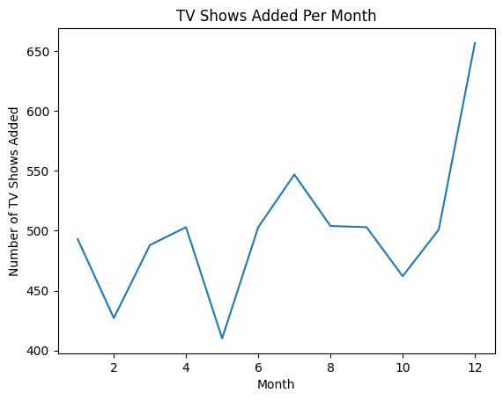

Observations:
Most public Netflix datasets show:
- Peak additions in February, May-June and October to December Month
- High activity also in December
- Lowest in August-September
Business Interpretation:
Best Time to Launch:
May
• Summer vacation in many countries
• High viewer engagement
• Less competition from traditional TV seasons
December
- Holiday season
- High binge-watching behavior

Analysis of actors/directors of different types of shows/movies.
# Data Preparation
import pandas as pd

# Drop missing values
df = df.dropna(subset=['cast', 'director'])

# Split cast column
df['cast'] = df['cast'].str.split(',')
df = df.explode('cast')
df['cast'] = df['cast'].str.strip()

# Split director column
df['director'] = df['director'].str.split(',')
df = df.explode('director')
df['director'] = df['director'].str.strip()

# Actor Analysis: Most Frequent Actors in Movies vs TV Shows
actor_type = df.groupby(['cast','type']).size().reset_index(name='count')

 | cast | type | count
0 | "Riley" Lakdhar Dridi | Movie | 3
1 | 'Najite Dede | Movie | 3
2 | 2Mex | Movie | 2
3 | 50 Cent | Movie | 8
4 | A. Murat Özgen | Movie | 2
... | ... | ... | ...
25938 | Şevket Çoruh | Movie | 2
25939 | Şinasi Yurtsever | Movie | 9
25940 | Şükran Ovalı | Movie | 2
25941 | Şükrü Özyıldız | Movie | 2
25942 | Ṣọpẹ́ Dìrísù | Movie | 2
25943 rows × 3 columns
Insights:
• Some actors appear mostly in Movies.
• Some actors dominate TV Shows.
• Very few actors dominate both categories equally.
# Director Analysis: Directors by Type
director_type = df.groupby(['director','type']).size().reset_index(name='count')
director_type
 | director | type | count
0 | A. L. Vijay | Movie | 42
1 | A. Raajdheep | Movie | 10
2 | A. Salaam | Movie | 30
3 | A.R. Murugadoss | Movie | 12
4 | Aadish Keluskar | Movie | 12
... | ... | ... | ...
4355 | Éric Warin | Movie | 36
4356 | Ísold Uggadóttir | Movie | 27
4357 | Óskar Thór Axelsson | Movie | 20
4358 | Ömer Faruk Sorak | Movie | 84
4359 | Şenol Sönmez | Movie | 48
4360 rows × 3 columns
Insights:
• Most directors specialize in Movies.
• Fewer directors consistently produce multi-season TV Shows.
• TV series often involve multiple directors per show.

Comparison:
Movies
- More unique directors
- One-time project format
- Higher actor rotation
TV Shows
- Repeated actors across seasons
- Fewer but more consistent directors
- Strong long-term collaboration patterns

- # Country-Wise Actor/Director Trend
- df.groupby(['country','cast','type']).size()

 |  |  | 0
country | cast | type
 | Ala' Hanani | Movie | 2
 | Ameer Khlawe | Movie | 2
 | Angie Saba | Movie | 2
 | Areen Omari | Movie | 3
 | Aude-Laurence Clermont Biver | Movie | 2
... | ... | ... | ...
Zimbabwe | Kudzai Sevenzo | Movie | 3
 | Michael Kudakwashe | Movie | 3
 | Tendai Nguni | Movie | 3
 | Tendaiishe Chitima | Movie | 3
 | Zihlo | Movie | 3
39401 rows × 1 columns
dtype: int64
Insights:
Zimbabwe- Movie-heavy actors
USA → Balanced industry

Business Insights:
- Sign actors with strong repeat presence in successful genres.
- Invest in directors who have consistent high-performing series.
- Identify cross-over talent (actors successful in both movies & series).
- Promote regional stars globally.

Does Netflix has more focus on TV Shows than movies in recent years.
# Compare Movies vs TV Shows Added Per Year
import pandas as pd

# Remove null values
df = df.dropna(subset=['date_added'])

# Clean spaces
df['date_added'] = df['date_added'].str.strip()

# Convert safely
df['date_added'] = pd.to_datetime(df['date_added'], errors='coerce')

# Drop invalid conversions
df = df.dropna(subset=['date_added'])

# Extract year
df['year_added'] = df['date_added'].dt.year

# Group
year_type = df.groupby(['year_added','type']).size().unstack(fill_value=0)

year_type

type | Movie | TV Show
year_added
2008 | 18 | 0
2009 | 30 | 0
2010 | 20 | 0
2011 | 438 | 0
2012 | 36 | 0
2013 | 75 | 30
2014 | 330 | 0
2015 | 1062 | 63
2016 | 4621 | 150
2017 | 17697 | 503
2018 | 27372 | 470
2019 | 32861 | 1224
2020 | 31419 | 2112
2021 | 21634 | 1008
Before 2015
- More Movies added than TV Shows
2015–2019
- TV Shows grow faster than Movies
- Netflix invests heavily in originals like Stranger Things, House of Cards, etc.
2019–2021
- TV Shows often outpace Movies in additions
- Especially after binge-watch format success
- Movies still added, but TV Show growth is stronger

- # Visualization
- import matplotlib.pyplot as plt

- plt.plot(year_type.index, year_type['Movie'], label='Movies')
- plt.plot(year_type.index, year_type['TV Show'], label='TV Shows')
- plt.xlabel('Year Added')
- plt.ylabel('Count')
- plt.title('Movies vs TV Shows Over Time')
- plt.legend()
- plt.show()

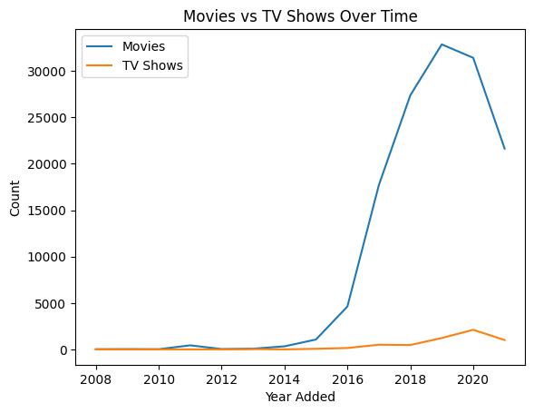

Business Insights:

TV Shows Might Be Focused More Recently because:
Retention
TV Shows keep subscribers longer (multi-season engagement)
Binge-watching Behaviour
Episodic content increases total watch time
Global Local Content
Different countries produce localized series
Netflix shows a stronger growth trend in TV Shows than Movies in recent years, and strategically this makes sense because:
- TV Shows drive longer user engagement
- They build series brand loyalty
- They are better for global content strategies
- They reduce churn compared to single movies

Understanding what content is available in different countries
# Clean the Country Column
# Remove missing country values
df = df.dropna(subset=['country'])

# Split multiple countries
df['country'] = df['country'].str.split(',')

# Create separate row for each country
df = df.explode('country')

df['country'] = df['country'].str.strip()

# Total Content by Country
country_count = df['country'].value_counts()
country_count

 | count
country
United States | 45773
India | 21762
United Kingdom | 9010
France | 6816
Canada | 5793
... | ...
Vatican City | 3
Sri Lanka | 2
Afghanistan | 2
Panama | 2
Nicaragua | 1
110 rows × 1 columns
dtype: int64
Observations:
• USA highest
• India high movie count
• UK, France, Canada strong presence

Movies vs TV Shows by Country
# Movies vs TV Shows by Country
df.groupby(['country','type']).size()

 |  | 0
country | type
 | Movie | 95
Afghanistan | Movie | 2
Albania | Movie | 8
Algeria | Movie | 77
Angola | Movie | 32
... | ... | ...
Vatican City | Movie | 3
Venezuela | Movie | 23
Vietnam | Movie | 134
West Germany | Movie | 60
Zimbabwe | Movie | 36
144 rows × 1 columns
dtype: int64

# Genre Distribution by Country
df['listed_in'] = df['listed_in'].str.split(',')
df = df.explode('listed_in')
df['listed_in'] = df['listed_in'].str.strip()
result = df.groupby(['country','listed_in']) \
.size() \
.reset_index(name='count') \
.sort_values(by='count', ascending=False)

result.head(20)

 | country | listed_in | count
976 | United States | Comedies | 8253
981 | United States | Dramas | 8129
367 | India | International Movies | 7012
363 | India | Dramas | 5542
973 | United States | Children & Family Movies | 4761
970 | United States | Action & Adventure | 4492
984 | United States | Independent Movies | 3895
1009 | United States | Thrillers | 2698
359 | India | Comedies | 2675
993 | United States | Romantic Movies | 2230
983 | United States | Horror Movies | 2076
995 | United States | Sci-Fi & Fantasy | 2053
949 | United Kingdom | Dramas | 1939
270 | France | International Movies | 1718
266 | France | Dramas | 1708
366 | India | Independent Movies | 1388
356 | India | Action & Adventure | 1187
985 | United States | International Movies | 1164
953 | United Kingdom | International Movies | 1157
826 | Spain | International Movies | 1102

Insights:
USA → Independent Movies, Thrillers, Romantic Movies
India → Comedies, Independent Movies, Action & Adventure
UK→ Dramas

# Recent Growth by Country
df['date_added'] = pd.to_datetime(df['date_added'])
df['year_added'] = df['date_added'].dt.year

df.groupby(['country','year_added']).size()

 |  | 0
country | year_added
 | 2019 | 27
 | 2020 | 26
 | 2021 | 42
Afghanistan | 2017 | 2
Albania | 2018 | 8
... | ... | ...
Vietnam | 2020 | 3
 | 2021 | 68
West Germany | 2019 | 30
 | 2020 | 30
Zimbabwe | 2020 | 36
414 rows × 1 columns
dtype: int64

Business Recommendations:
- Use country-specific content strategy
- Invest in high-performing genres per region
- Promote regional hits globally
- Increase series production in movie-heavy countries

